**Type Conversion in Python**

Two types of Type Conversion in Python:

1. Implicit Type Conversion
2. Explicit Type Conversion

Implicit type conversion of data types in Python

* The Python interpreter automatically converts one data type to another without any user involvement.

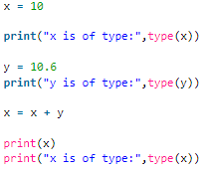 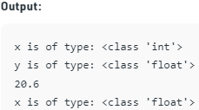

In Explicit Type Conversion in Python

* The data type is manually changed by the user as per their requirement.

**1. int(a,** **base)**: This function converts**any data type to integer**. ‘Base’ specifies the**base in which string is** if the data type is a string.  
**2. float()**: This function is used to convert **any data type to a**floating-point**number**

# Python code to demonstrate Type conversion

# using int(), float()

# initializing string

s **=** "10010"

# printing string converting to int base 2

c **=** int(s,2)

print ("After converting to integer base 2 : ", end**=**"")

**print** (c)

# printing string converting to float

e **=** float(s)

**print** ("After converting to float : ", end**=**"")

print (e)

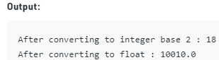

# Python code to demonstrate Type conversion

# using  ord(), hex(), oct()

# initializing integer

s **=** '4'

# printing character converting to integer

c **=** ord(s)

**print** ("After converting character to integer : ",end**=**"")

**print** (c)

# printing integer converting to hexadecimal string

c **=** hex(56)

**print** ("After converting 56 to hexadecimal string : ",end**=**"")

**print** (c)

# printing integer converting to octal string

c **=** oct(56)

print ("After converting 56 to octal string : ",end**=**"")

print (c)

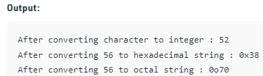

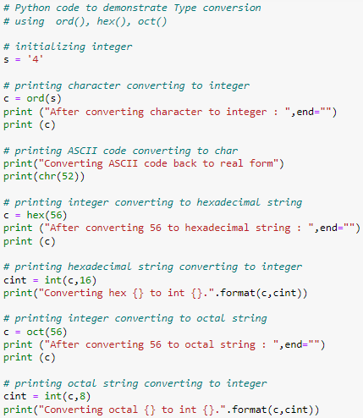

Output:

